**InvoPlace**

An app by Sumanyu Aggarwal

**Topic –** Idea Pitching Marketplace

InvoPlace is an app that helps aspiring innovators share their ideas with the world and receive funding for them from prospective investors.

Made with **Flutter** and **Firebase**.

To get started register on the app. You will be signed in.

**Dashboard**

Here you can view your ideas or the ideas of others to invest in. At the bottom, you can also change the theme of the app.

**Your Ideas**

On this page you can view all your uploaded ideas. Swipe right on an idea to delete it.

**View Investors**

Here you can see the people who invested in your idea. Say them Thank You!

**Upload Idea**

To upload your idea, you need to provide a title and a description of your idea. You can also provide a video (pitch) of your idea. It is optional but is recommended.

**Invest in Other Ideas**

View ideas uploaded by other here. You hide the ideas you have already invested in and also filter the ideas by country.

**Idea Details**

Details of the idea along with the information of the uploader. You can contact them to talk about the idea and when you are ready, you can invest in it.

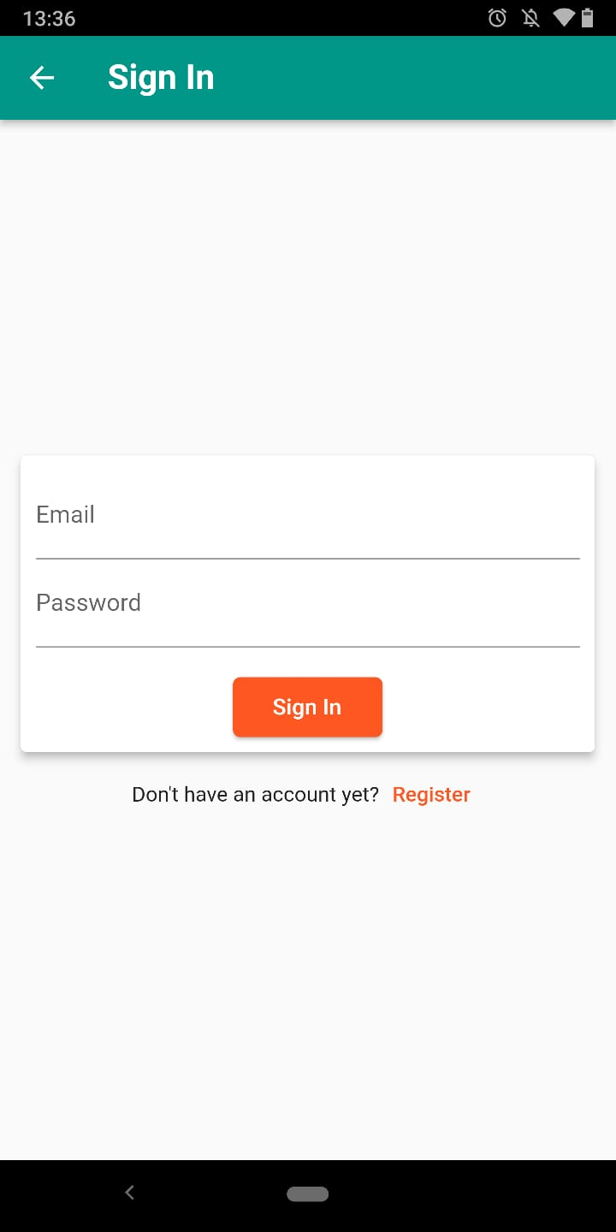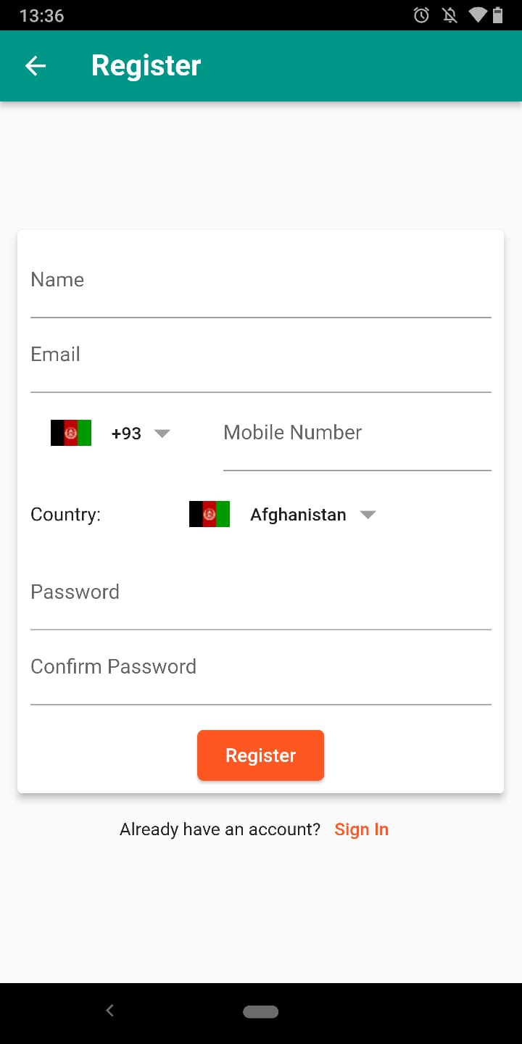**Gallery**

Register

Home

Sign In

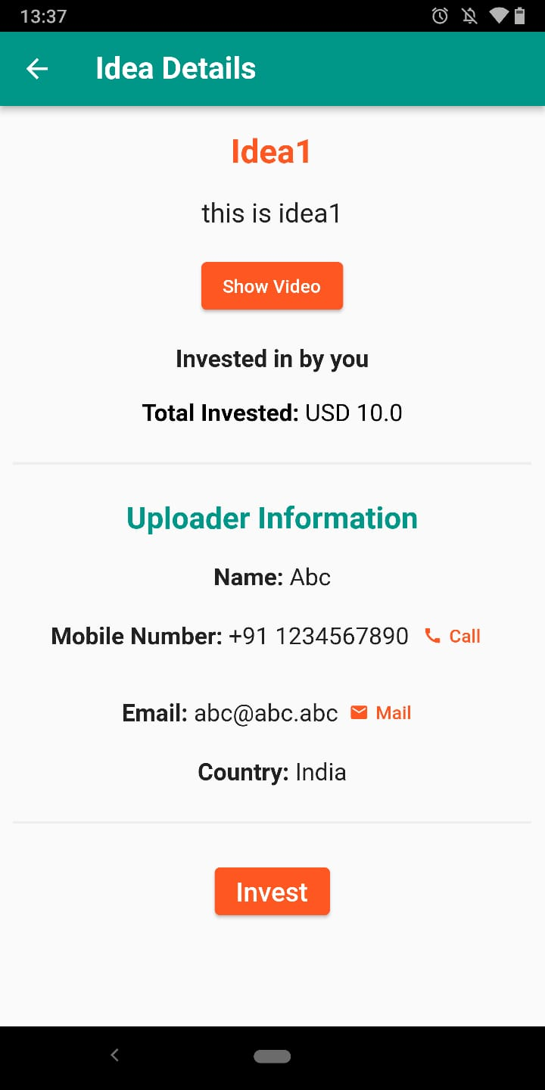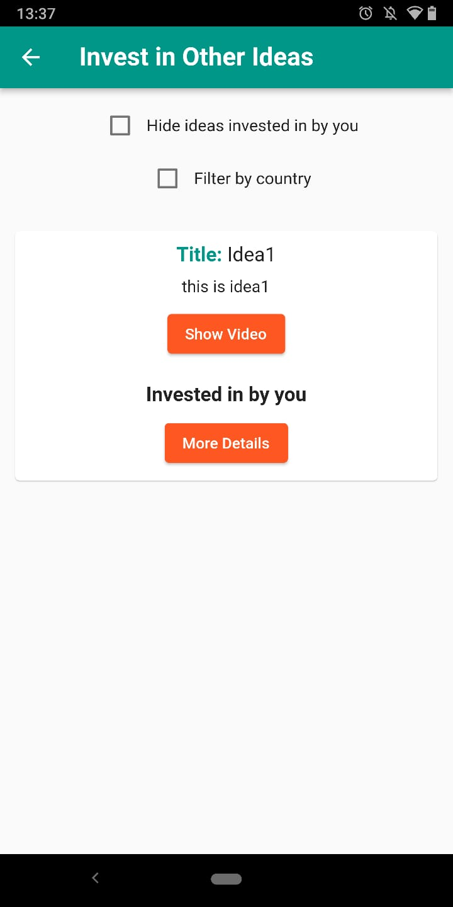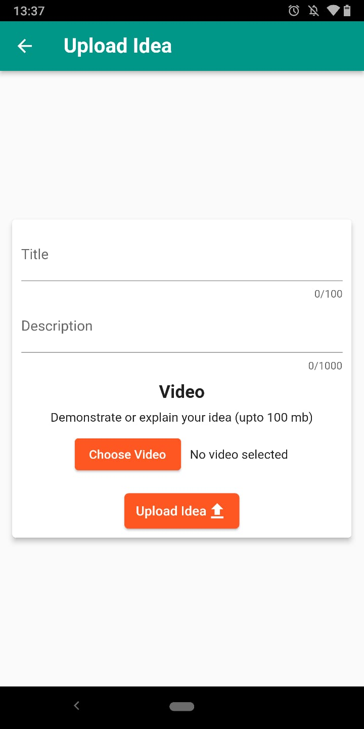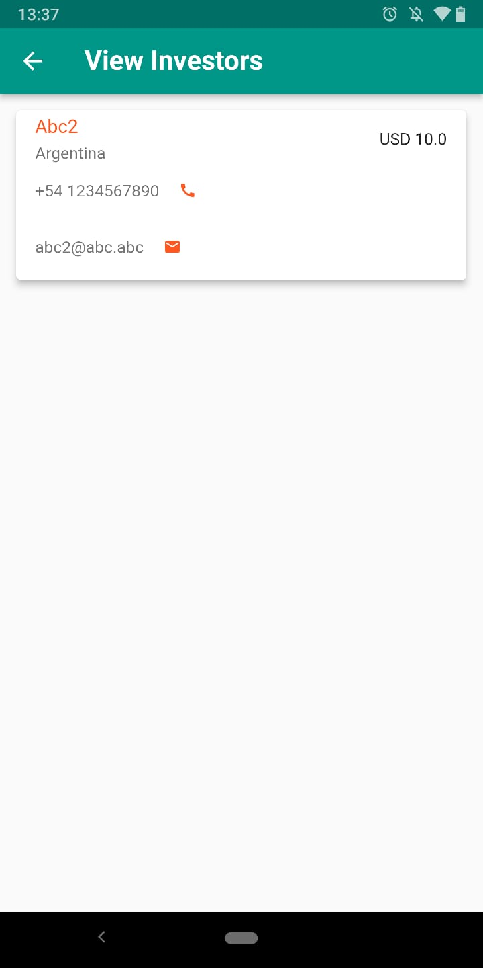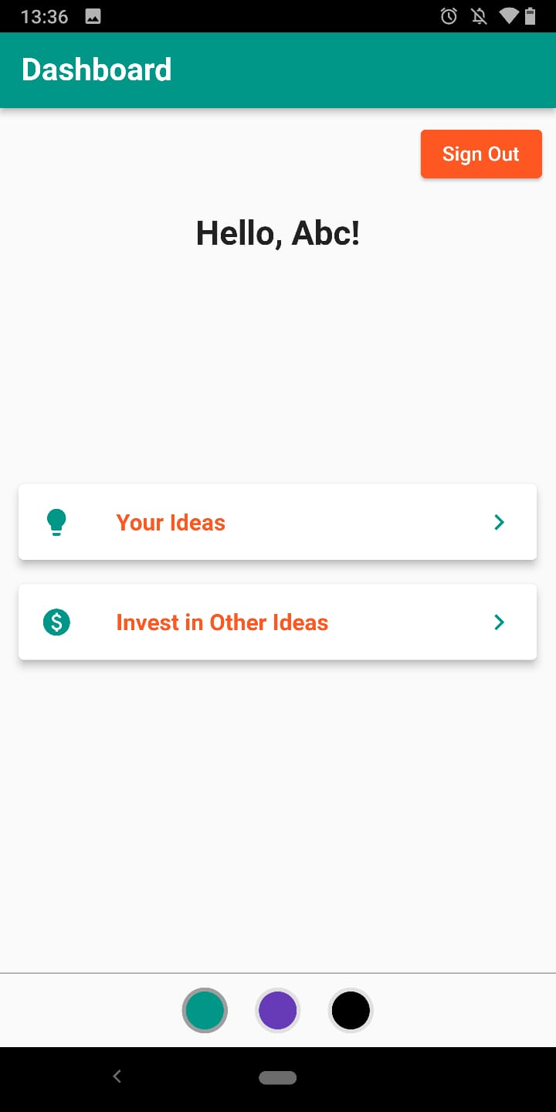

Invest in Other Ideas

Idea Details

Upload Idea

View Investors

Your Ideas

Dashboard

**Submitted by:** Sumanyu Aggarwal

**Class:** 9

**School:** Indraprastha World School